**ServiceNow NaanMudhalvan Project**

**Musunuru Pavan**

**au723921244033**

**Project:** Effective Knowledge Management: From Article Creation to Approval

**Email**: musunurupavan183@gmail.com

**Implementation**

**Activity-1: Create Users**

1. Open service now.
2. Click on All >> search for users
3. Select Users under system security
4. Click on new
5. Fill the following details to create a new user
6. Click on Submit.

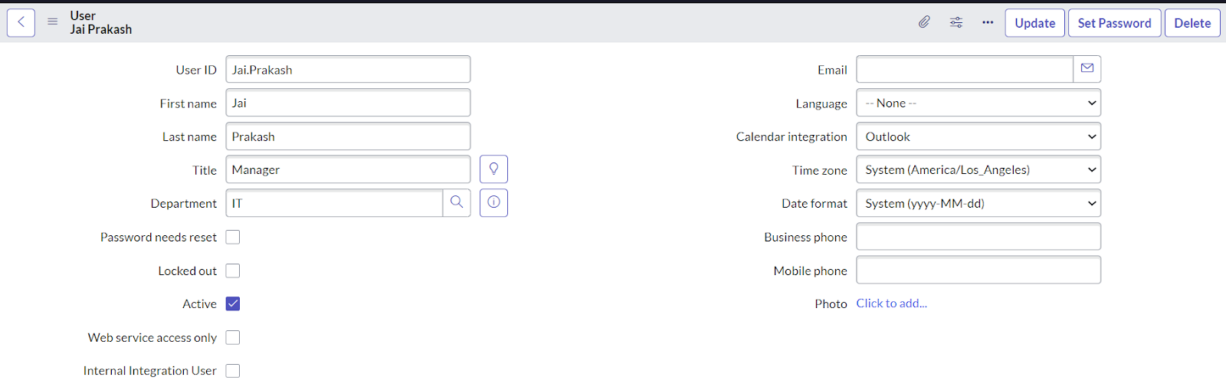

**Activity - 2: Create Groups**

1. Open service now.
2. Click on All > search for groups
3. Select groups under system security
4. Click on new
5. Fill the following details to create a new group.
6. Under Group Members, click on edit.
7. Add the user (Jai Prakash) to the Manager Group and click on Save.

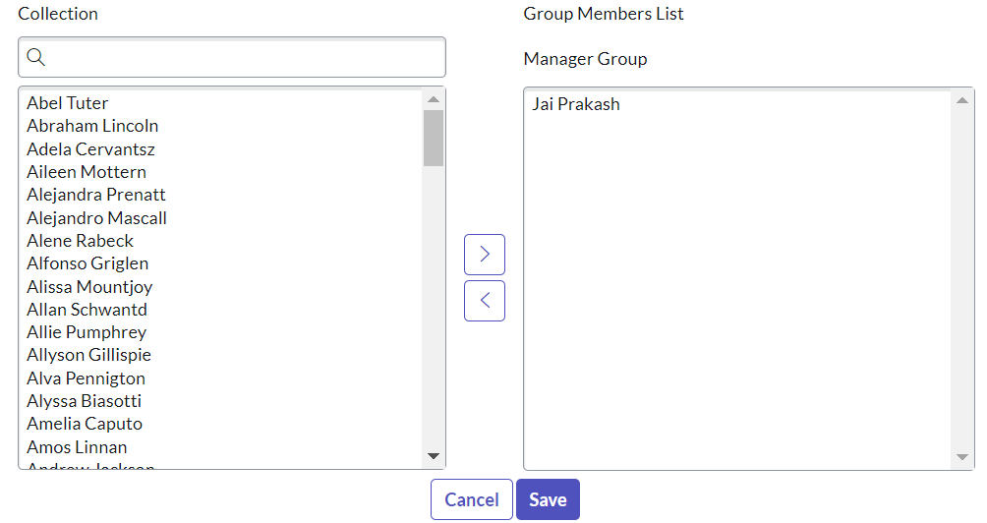

**Activity - 3: Create Roles**

1. Open service now.
2. Click on All > search for roles
3. Select roles under system security
4. Click on new
5. Fill the following details to create a new role
6. Click on submit.

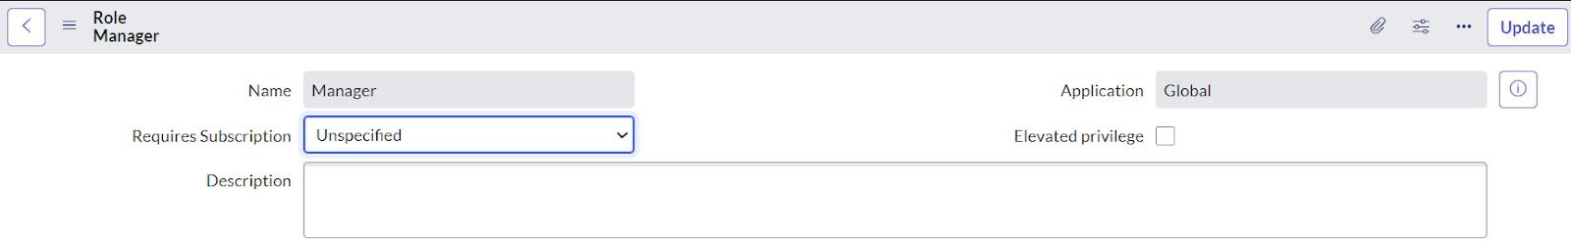

**Activity - 4: Changing the Owner of the Knowledge Base**

1. Go to All >> Search for Knowledge Bases.
2. Open Knowledge bases and change the of IT from Bernard Laboy to Jai Prakash (To change Owner click on the Name and change it)

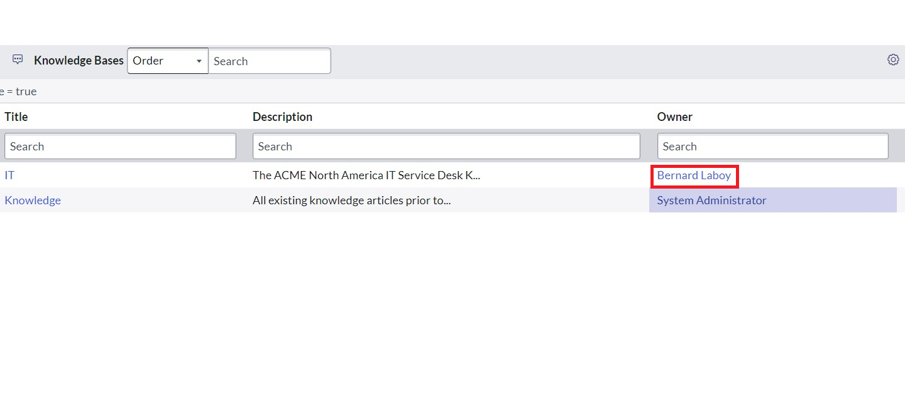

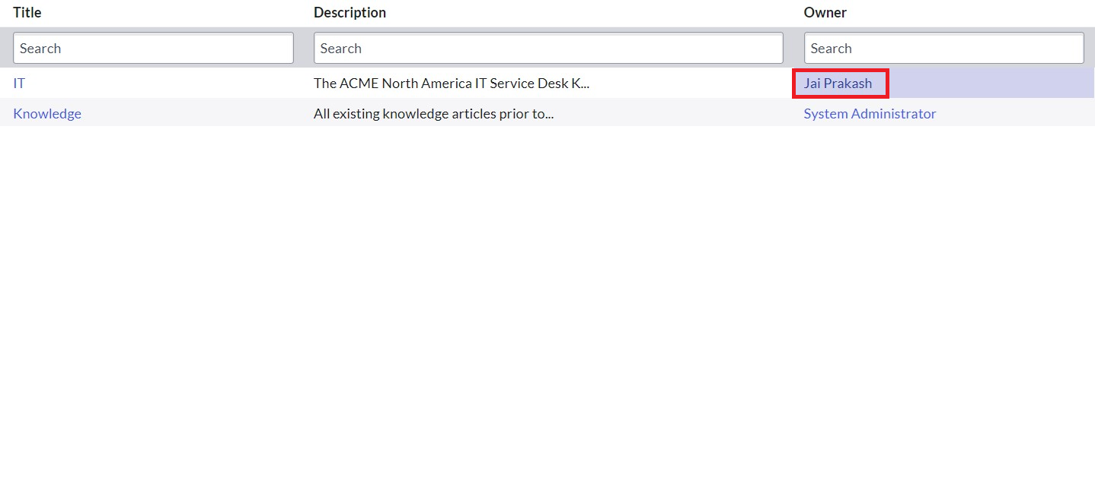

**Activity - 5: Creation of Knowledge Article.**

1. Go to All >> Search for my knowledge Articles.
2. Open my knowledge Articles >> Click New.
3. Fill the details as below:

Number: Auto-generated.

Knowledge base: IT

Category: Select any category

Short description: Describes about Cloud Computing. (Give Short description as per your requirement)

1. Click on Submit.
2. Click on Publish.
3. Open that Knowledge Article again.
4. We can see that the Knowledge Article has been assigned to the user you created under approvals.

**Below article I have prepared based on the cloud computing**

**Exploring the World of Cloud Computing: Revolutionizing IT**

Cloud computing has revolutionized the way businesses and individuals access, store, and manage their data and applications. At its core, cloud computing refers to the delivery of computing services—including servers, storage, databases, networking, software, and more—over the Internet ("the cloud"). This model offers a variety of benefits, from cost savings to increased efficiency and flexibility.

**Key Characteristics of Cloud Computing**

1. **On-Demand Self-Service:** Users can provision computing capabilities as needed without requiring human interaction with service providers. This means you can access the resources you need, when you need them, directly from an online interface.
2. **Broad Network Access:** Cloud services are available over the network and accessed through standard mechanisms, allowing for a wide range of devices (e.g., mobile phones, tablets, laptops) to interact with them.
3. **Resource Pooling:** Cloud providers use a multi-tenant model to serve multiple consumers with a pool of computing resources, dynamically allocating and reallocating resources according to demand.
4. **Rapid Elasticity:** Capabilities can be elastically provisioned and released, often automatically, to scale rapidly outward and inward commensurate with demand. This ensures that you can handle fluctuating workloads without the need for massive infrastructure investments.
5. **Measured Service:** Cloud systems automatically control and optimize resource use by leveraging a metering capability at some level of abstraction appropriate to the type of service (e.g., storage, processing, bandwidth). This provides transparency for both the provider and the consumer.

**Types of Cloud Services**

1. **Infrastructure as a Service (IaaS):** Provides virtualized computing resources over the internet. IaaS offers basic computing resources such as servers, storage, and networking. It allows users to run any software, including operating systems and applications. Examples include Amazon Web Services (AWS), Microsoft Azure, and Google Cloud Platform.
2. **Platform as a Service (PaaS):** Offers hardware and software tools over the internet. PaaS delivers a framework for developers to build upon and create customized applications. Examples include Google App Engine, Microsoft Azure, and Heroku.
3. **Software as a Service (SaaS):** Delivers software applications over the internet, on a subscription basis. SaaS provides a complete software solution that you purchase on a pay-as-you-go basis from a cloud service provider. Examples include Google Workspace, Microsoft Office 365, and Salesforce.

**Benefits of Cloud Computing**

* **Cost Efficiency:** Reduces the capital expense of buying hardware and software and setting up and running on-site datacenters.
* **Scalability:** Offers the ability to scale resources up or down based on demand, providing businesses with the flexibility to handle fluctuating workloads.
* **Performance:** Provides high-performance resources that can be quickly and easily provisioned to suit user needs.
* **Security:** Offers advanced security features and compliance certifications, ensuring that data is protected from unauthorized access.

**Conclusion**

Cloud computing continues to evolve, offering new opportunities for innovation and efficiency. It enables businesses to be more agile, scale operations quickly, and stay competitive in a fast-paced digital world. As technology advances, the capabilities and applications of cloud computing will only continue to expand, making it a crucial component of modern IT infrastructure.

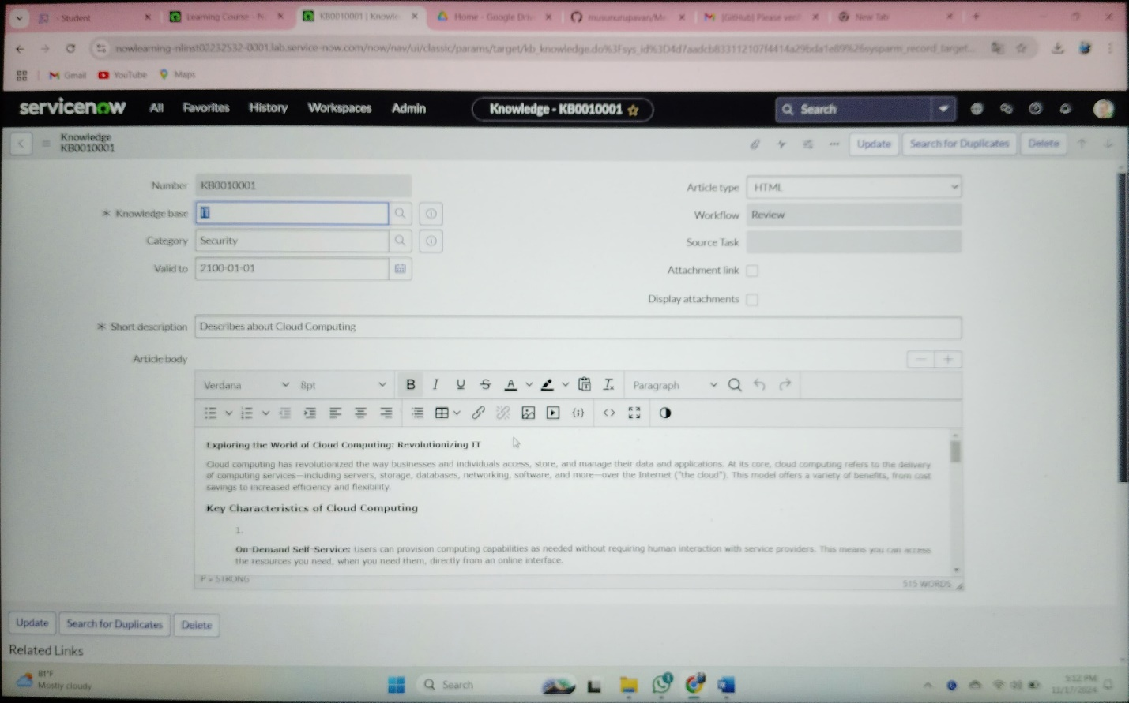

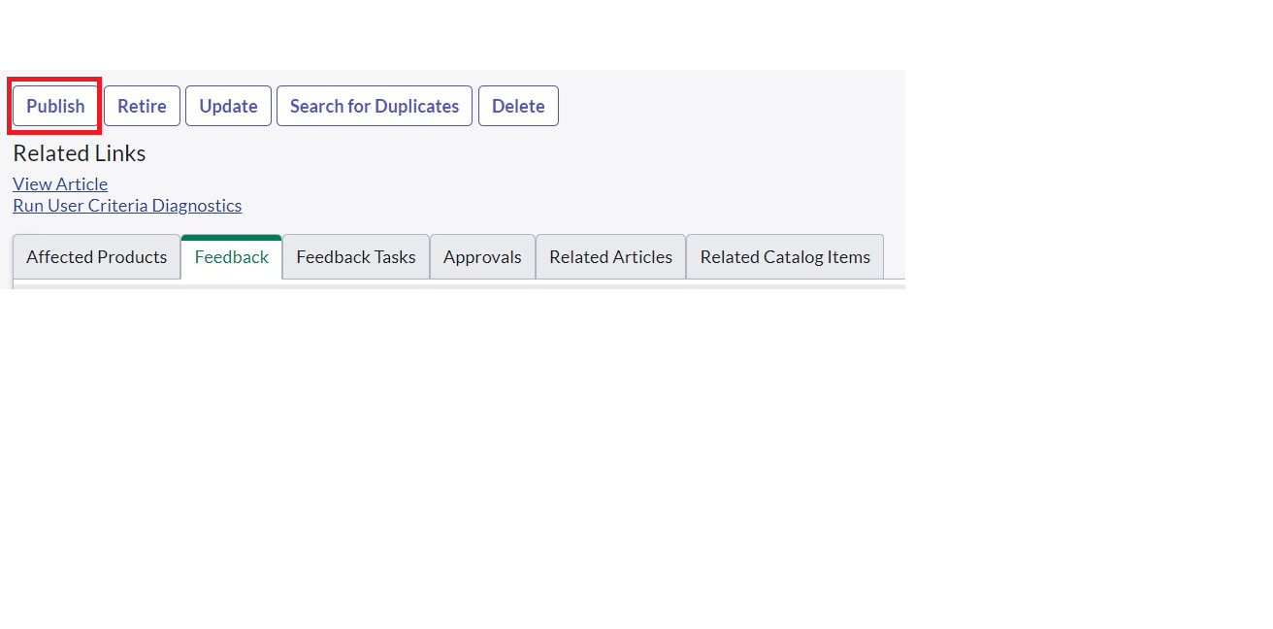

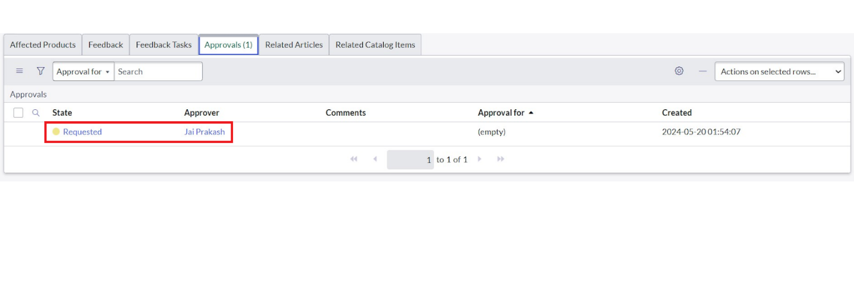

**Result**

1. To verify whether the email is sent for approval or not.
2. Go to All, search for emails.
3. Under System logs click on emails.
4. There you can see that the email has been sent.

